|  |
| --- |
| swansea metropolitan university |
| The potential effect of COLLADA on the games content development pipelines |
| Content pipeline tool development |
|  |
| **Sion Williams** |
| **5/19/2008** |

|  |
| --- |
|  |

Contents

Introduction 3

The content pipeline 3

Current Games Pipelines 3

Stage 1 Source 4

Stage 2 Intermediate 4

Stage 3 Final/ Runtime 5

The COLLADA content pipeline 5

Conclusion 6

Bibliography 7

# Introduction

COLLADA (COLLAborative Design Activity) was created as an effort to establish an interchange file format for DCC (Digital Content Creation) tools like *Autodesk Maya* and *3DS Max* and game engines like *Unreal Engine 3* or *OGRE 3D* and then finally shader designers like *NVIDIA FX composer* or *ATI RenderMonkey*.

The applications named above produce and/or operate on content. Unfortunately, as each piece of software is from different developers, each one uses its own proprietary file format, this makes interoperability very difficult. COLLADA was developed to overcome this problem and was created using an XML based file format.

# The content pipeline

The content pipeline is the process by which content is created, exported into a supported format, tweaked for optimal use within the game, and finally imported for use within the game. The content pipeline is comprised of the following elements:

* Digital Content Creation (DCC) tools: these tools are used by the artists to create the source data, it must also be noted that many computer games developers refer to the source data as an asset.
* An Exporter: a program written for a given DCC tool that allows the user to extract the content from the DCC tool. Typically known as plug-ins.
* The conditioning pipeline: conditioners, small functions that apply several transformations to the content such as geometry cleaning and optimising for fast rendering. It can also be used for changing between left and right hand co-ordinate systems. *COLLADA* has released its own content pipeline tool for *COLLADA* called *COLLADA* *Refinery* (4).
* The runtime database: encoding for a specific runtime or in a games console sense for a given target platform.

## Current Games Pipelines

shows the game content pipeline for MechAssault 2 that was developed by Day 1 studios. Although the game was released in 2004, the procedure is very much the same in today’s development cycle; a very similar content pipeline has been presented at Siggraph in 2007 by *LucasArts* for their new game *Star Wars: The Force Unleashed* (5). Although only shows the model, animation and texture pipeline, far more pipelines exist:

* Animation pipeline
* Facial Animation pipeline
* Model pipeline
* Texture pipeline
* FMV(movie sequence) pipelines
* General Scripting pipeline
* Fight Scripting pipeline
* Lighting pipeline
* Localization pipeline
* Sound pipeline
* Physics cloth simulation pipeline
* World builder pipeline

The list given above are the pipelines documented in the content pipeline specification for *Dark Angel* that was created by *Radical Entertainment* (1).

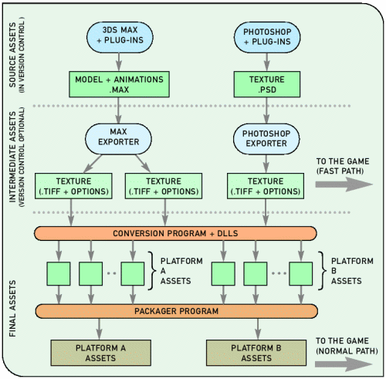

Figure A partial view of MechAssault2 content pipeline (only models and textures shown)

As we can see there are 3 stages, source asset, intermediate asset and final asset. These are also known as source format, intermediate format and runtime format.

### Stage 1 Source

The source assets are the files created by artists and designers, usually with tools like *Autodesk Maya* or *3DS Max,* tools that have been developed in house are also used. Depending on the pipeline that is being worked on, the software used to create an asset can be very different, for example one tool may be used for modelling, one for texture creation, one for specifying game information, one to lay out a level and on other times one large tool is used to create all assets and export full levels. At this level all game data should be provided with the asset, for example where the bullet fires from on a gun etc.

### Stage 2 Intermediate

Intermediate assets are the result of exporting the source asset from the DCC, usually via the form of a plug in when using off the shelf software. These intermediate assets are always stored in an easy to parse, read and revert back to standard format. At this stage of the pipeline all information should be provided with an asset, even if the information gets discarded before then final stage, every asset should be complete.

For many companies the preferred file format is a plain text format but when several assets are created this can become very awkward to handle, especially when everything is stored in separate files in different formats. In previous years companies have adopted XML to help structure the text files when they need to represent the information hierarchically as this allows them a range of tools and API’s to edit, parse and transform files with minimum effort. This is why *COLLADA* was introduced. “COLLADA’s goal is to foster the development of a more advanced content pipeline by standardizing a common intermediate representation, encouraging better quality content, and bringing many advanced features to the standard.” What this means is that by having everything export and import a well defined common format, developers would not need to write and maintain their own exporters and the data would be available directly to the content pipeline.

### Stage 3 Final/ Runtime

At this stage the asset should be highly optimized so they can be used as efficiently as possible in their targeted platform. The type of operations done at this stage range from quick ones such as simple format changes, to somewhat expensive ones such as mip-map generation, dithering, or compression, to really time-consuming ones such as lightmap generation and mesh optimizations.

## The COLLADA content pipeline

One major problem developer’s face when using DCC tools is that file formats are never the same. Now that the industry has a standard it’s fair to say that this problem will be reduced.

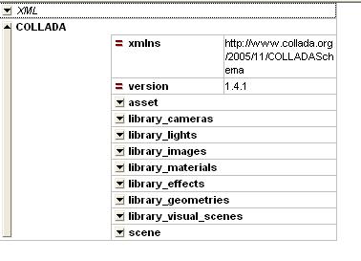

Figure COLLADA document viewed in XMLSpy

Figure 2 shows a typical *COLLADA* document. As we can see there are several parts of the file, typically each one of the libraries would be a separate file in a non-*COLLADA* pipeline. It’s instantly visible the benefit of *COLLADA*, if any changes are to be made to the document, it can be done without disrupting any other aspect of the asset. Another advantage of being able to re-import the intermediate format is time, where as previously the asset would need to be converted back to the DCC format, this step is completely removed.

# Conclusion

The use of XML is not new technology, Day 1 studios had documented their use of XML to structure their assets in 2004. The standardization of *COLLADA* should publicise it more and effectively increase its support. Tim Sweeney has adopted *COLLADA* for the development in his Unreal game engine, quite possibly one of the most acclaimed in the world.

I personally believe that *COLLADA* is going to become very popular with due time. As more companies support the format, the more documentation will appear and the more it will develop. An example of the impact *COLLADA* has already had from a development perspective is that of the Unreal Engine, the creators had written importers for five scene file formats, and export plug-ins for three major 3D applications. The time to develop these type of tools is time taken away from the game development, this could be the difference between getting a game released and not finishing in time and losing support for the project.

# Bibliography

1. *Dark Angel Content Pipeline Specification.* **Adam King, Bert Sandie.** 1.1, s.l. : Radical Entertainment, 2001.

2. **Remi Arnaud, Mark C.Barnes.** *COLLADA sailing the gulf of 3d digital content creation.* s.l. : AK Peters, 2006. 1-56881-287-6.

3. **Llopis, Noel.** Optimizing the Content Pipeline. *Games from Within.* [Online] 3 August 2004. [Cited: 2008 May 19.] http://www.gamesfromwithin.com/articles/0408/000027.html.

4. COLLADA Refinery. *COLLADA.* [Online] Khronos, 28 March 2007 . [Cited: 19 May 2008.] http://www.collada.org/mediawiki/index.php/COLLADA_Refinery.

5. *Content Pipelines.* s.l. : LucasArts, 2007. http://meshula.net/wordpress/?page_id=100.

6. **Sweeney, Tim.** Epic Games, CEO.